Special Topics Report

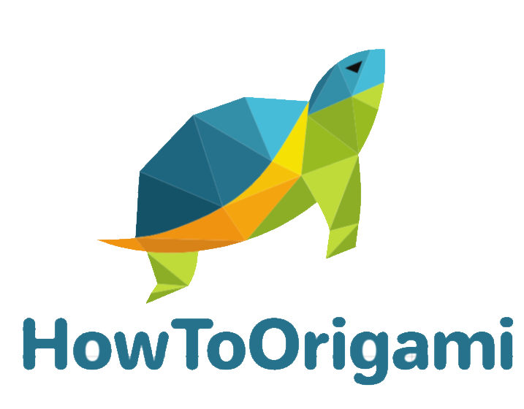

Submitted To: Dr. Raneem Qaddoura

Eng. Shatha Alhawawsheh

Date of submission: 8/5/2020

Submitted by: Zayna Amierh 18110041

2020

Table of Contents

2 Introduction 3

2.1 Website Plan 3

3 Responsive Design 3

3.1 The Goals 4

4 HTML and CSS Best Practices 4

4.1 Use a CSS Reset 4

4.2 Minify CSS 5

4.3 Use Meta Tags 6

4.4 Mobile-First 6

4.5 Use an Unordered List (<ul>) for Navigation 9

4.6 Always use External CSS 10

4.7 Use the Right HTML Element at the Right Place 10

4.8 Make sure All HTML Tags are Closed 11

4.9 Use Alt Attributes with Images 11

4.10 Use Meaningful ID and Class Naming 12

4.11 Use the Title 12

4.12 Logo should go to Home 13

4.13 Backup Fonts 13

4.14 Comments 13

5 Structural Elements And Responsive Design 14

5.1 Structural Elements 14

5.1.1 <nav> Tag 15

5.1.2 <header> Tag 15

5.1.3 <section> Tag 16

5.1.4 <aside> Tag 17

5.1.5 <article> and <p> Tag 20

5.1.6 Footer Tag 21

5.2 Use of Responsive Design 22

5.2.1 Responsive Typography 23

5.2.2 Media Queries 23

5.2.3 Mobile-First 25

5.2.4 Layout 25

6 CSS Cascade 26

6.1 Inline Style 27

6.2 ID 28

6.3 Class 29

6.4 Inherited 30

7 References 32

# Introduction

Have you ever wondered how you could create the best website to grab the attention of your customers and end users? Have you ever thought how you could make the website highly available to your customers regardless of what kind of device they may use? Well I have been hired as a full stack developer at “The Development Experts” Company to help them implement a full web-based solution for their customers. My role is to develop a full functional responsive web application with the aim to provide Origami instructions listing to the customers in which they can be able to interact with the web application through accounts.

## Website Plan

Thinking about how I can implement this web application gave me so many ideas that would be perfect for the theme. First of all, the website will be focusing on Origami instructions for different categories, and these can only be accessed if the user has an account. They will be able to learn many different origami shapes, games, and even packaging and this is perfect since the website can target all age groups. The requirements of the website will include:

1. Home page, contact page, about us page, categories page, and details page, in addition to the sign in and sign up page.
2. Best HTML and CSS best practices
3. Structural elements
4. Responsive design techniques
5. CSS techniques along with media queries and efficient navigation.
6. Responsive layout
7. CSS cascade

Let’s move on forward with the plan.

# Responsive Design

Thinking about the website and its content is important but how can we make the website available on all sorts of devices without any issues? How can we make our website responsive? What is a “Responsive Design”? Simply, it is the way to make websites that can be easily viewed and used on any size of screen or type of device whether it is the small mobile phone or a widest desktop monitor. Thus, a responsive design can help make your webpage look good on all devices. This is done with the use of CSS and HTML to resize, shrink, enlarge or move content to make it look satisfactory on any screen.

A Responsive Design is an approach that suggests that the design and development should respond to the user’s behavior and environment of screen size, platform, and orientation (portrait – landscape). It consists of a variety combination if flexible grids and layouts, responsive images, and the use of CSS media queries. When switching the device, the website should adapt with resolution, image size and scripting abilities. And for this, we should consider the viewport which is the user’s visible area of the web page since it varies with the device. (Responsive Web Design - What It Is And How To Use It — Smashing Magazine, 2020)

## The Goals

There are many ways to implement a responsive design of a website yet they all have the same goal of creating a website that can dynamically change depending on the screen size of the device in which the web page is viewed on. It is one solution to the problem of designing one website (instead of many) for the many devices. Instead of maintaining multiple codebases for each device that you wish to support, it aims to use a single codebase that adapts appropriately to each device in which many of the styles and elements in the responsive design can even be reused or built upon for maximum code efficiency. Thus, we can build web pages that detect the visitor’s screen size and orientation and change the layout accordingly. (The Meaning and Purpose of Responsive Web Design — SitePoint, 2020)

There are many reasons why we should adopt and apply a responsive web design; they include:

* Best practice for smart-phone optimized websites.
* SEO to help rank your website at the top within search engines.
* Responsive design gives positive user experience.
* Highly adaptable in the future according to changing technological trends so you can invest in a long-term design.
* Save time and money.

(Jensen, 2020)

# HTML and CSS Best Practices

In very website there are some best practices that should be followed in order to develop the best website and lead to clean and correct markup.

## Use a CSS Reset

It is essential to make sure you reset the CSS before beginning, this is because not all browsers apply the same default styling to the HTML elements. Therefore, the CSS reset will ensure that all elements do not have a specific style and you can be able to define your own without risking the browser issues that could be encountered.

This is the CSS reset found in my stylesheet:

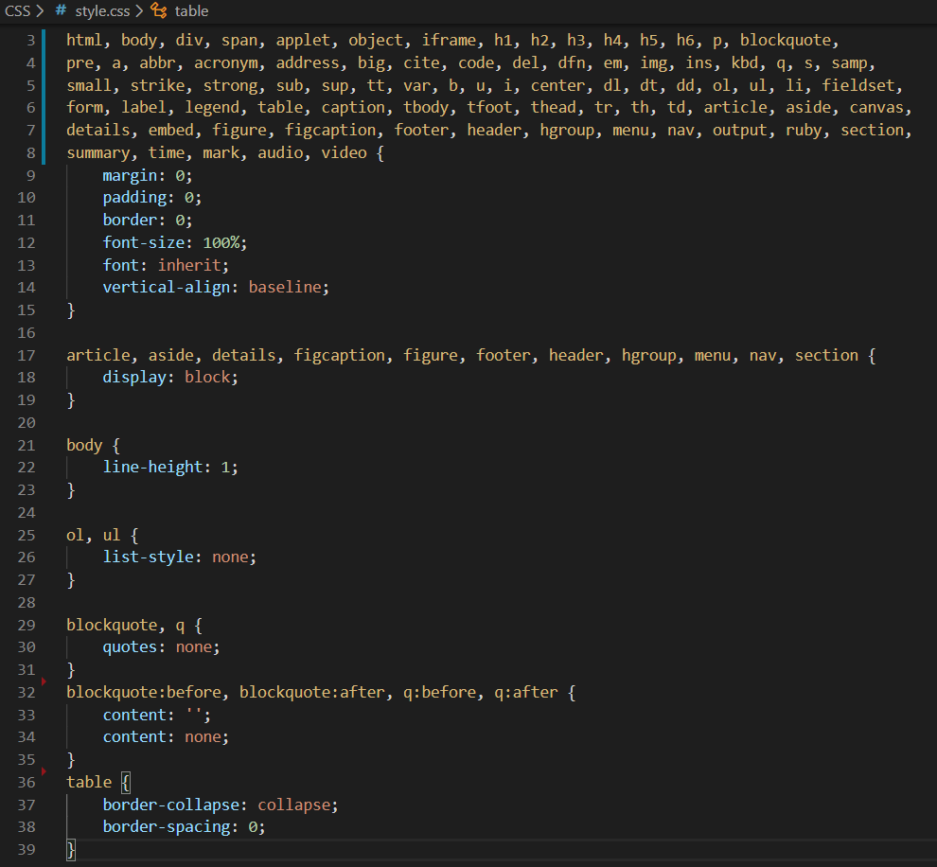

## Minify CSS

It is essential to minify the CSS files since each CSS file must make a HTTP request, which will slow down the websites load time. So, minifying the CSS take out unneeded characters such as spaces, newlines, and tabs all from the code to improve the load time of the website.

These are the files that I have minify:

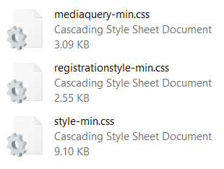

Section of the media-query file minified:

Section of the style CSS file minified:

Section of the registration CSS file minified:

## Use Meta Tags

The meta tags are essential to be added to your website for responsiveness due to the viewport meta attribute which gives the instructions to the browser to decide on what the size of the website should be displayed so it fits properly in the viewport. The value width=device-width tells the browser to render the page at full size..

Note: The viewport meta element is something that generally wasn’t used for most nonresponsive websites in the past, but is key to making your responsive site work.

## Mobile-First

Mobile first is one of the best practices that must be followed when creating a website since it ensures and guarantees that the website can be viewed on any device or screen. Below is an example:

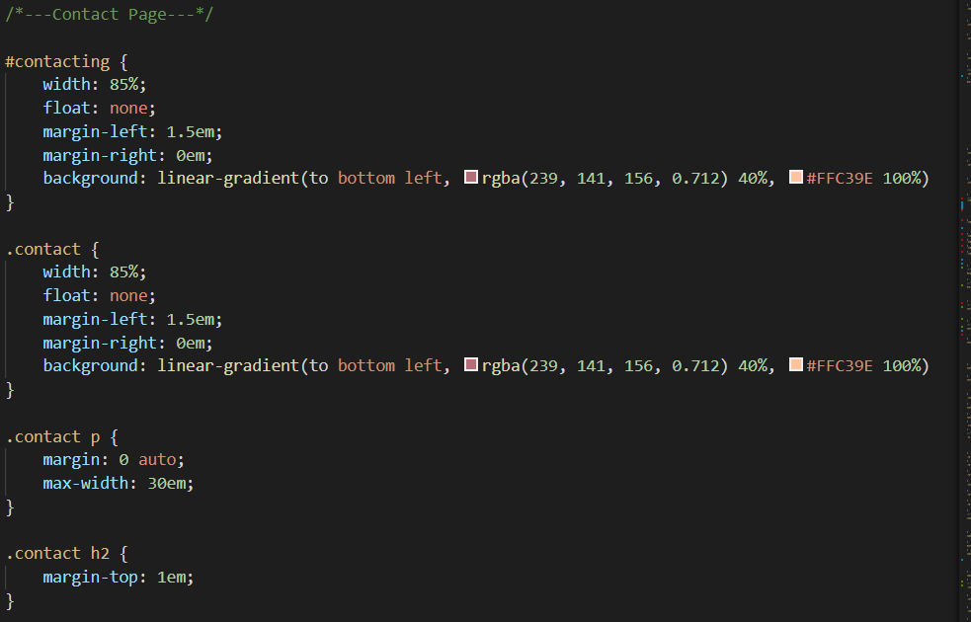

This is the code that will be implemented on small screens and it will look like this:

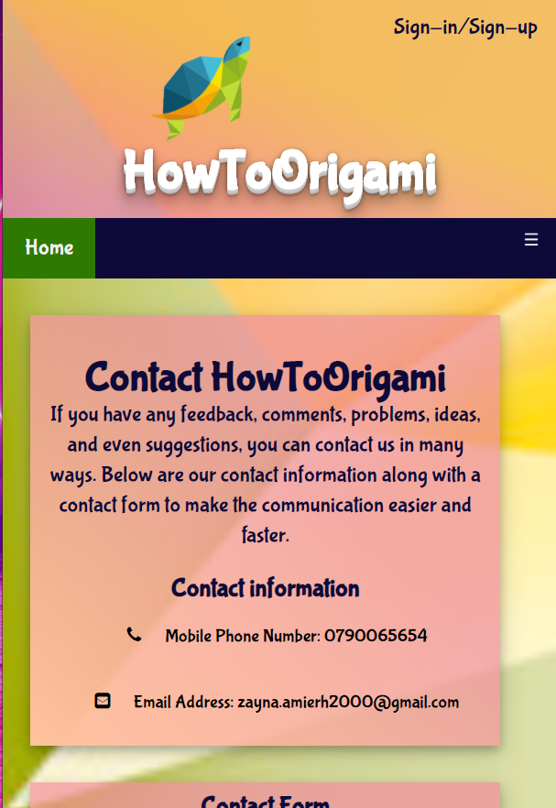

While on larger screens, the below code will be implemented:

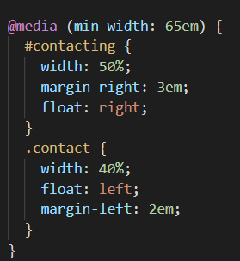

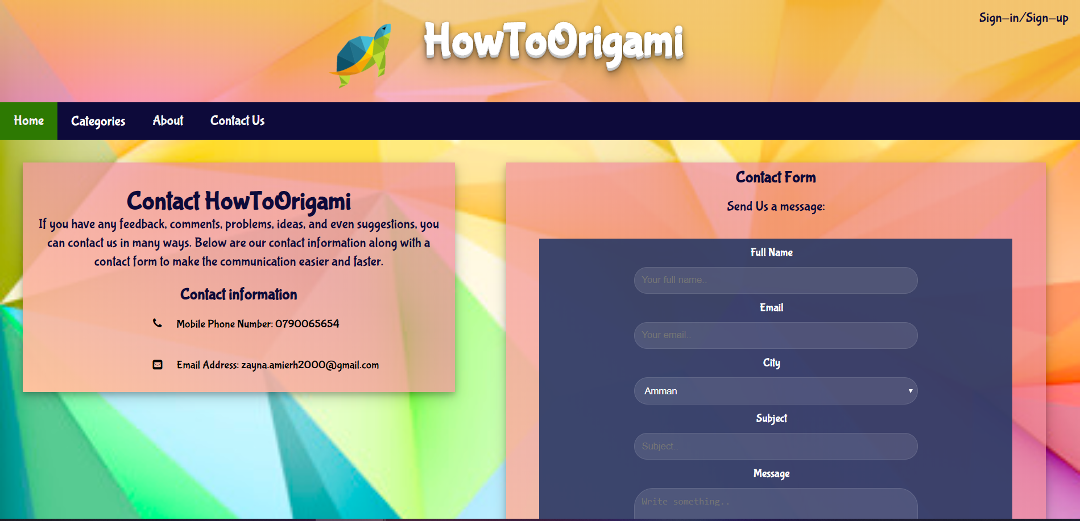

## Use an Unordered List (<ul>) for Navigation

Due to the fact that navigation is extremely important in the website design, the ul element combined with CSS makes the navigation menus semantic. Also, the unordered list for the navigation menu has been the accepted markup. Here is from my website:

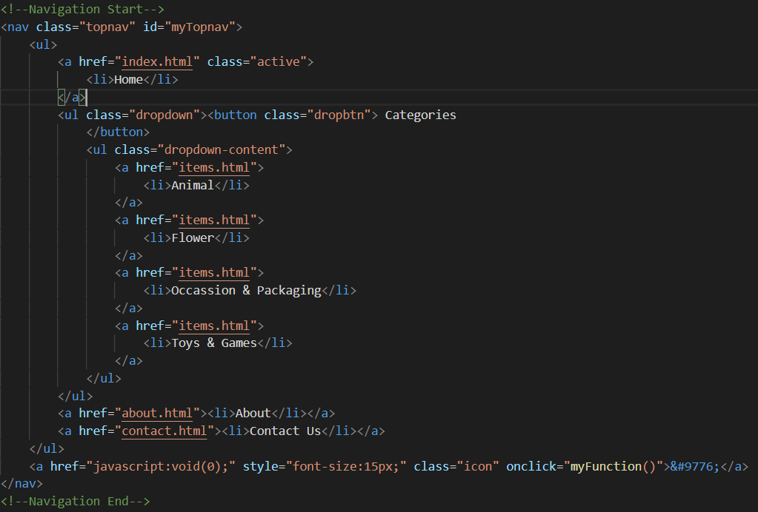

## Always use External CSS

It is one of the best practices to put the CSS in an external file since all style changes are done inside that single stylesheet and a single CSS will be cached and page will load faster.



## Use the Right HTML Element at the Right Place

All elements in the html should be used correctly throughout the website and this will be beneficial for the user to know where each content is and it will most importantly help the Search Engine Optimization.

Here are two examples:

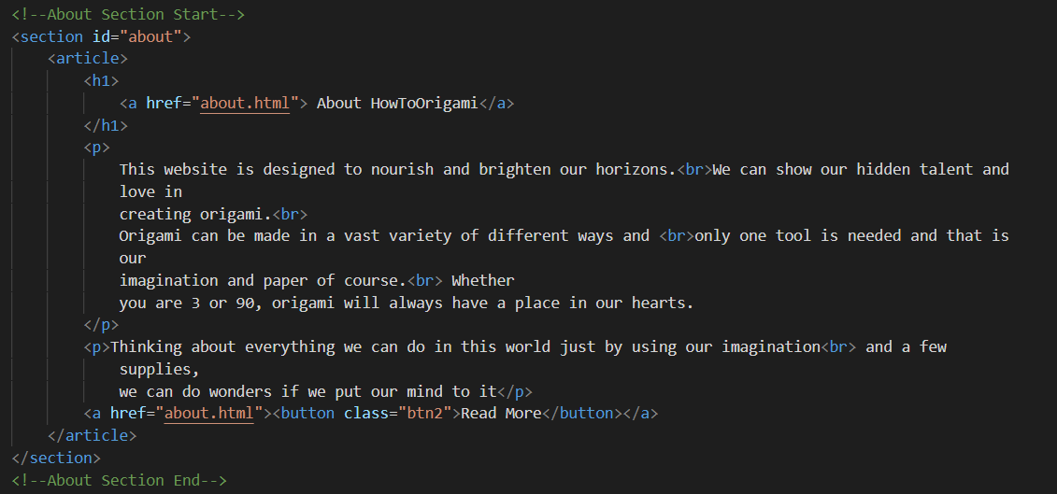

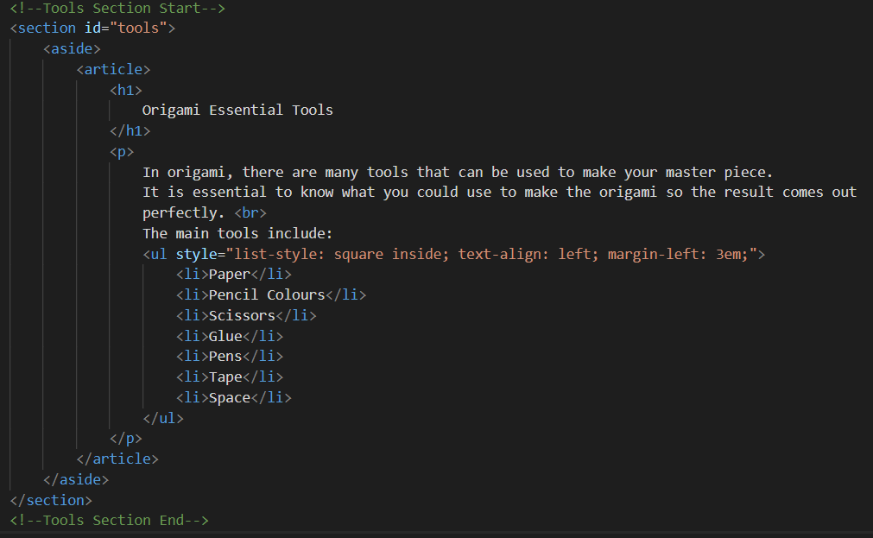

## Make sure All HTML Tags are Closed

All HTML tags should be closed since not closing the tags is invalid under standards. All tags have been closed in my website. Below is an example:

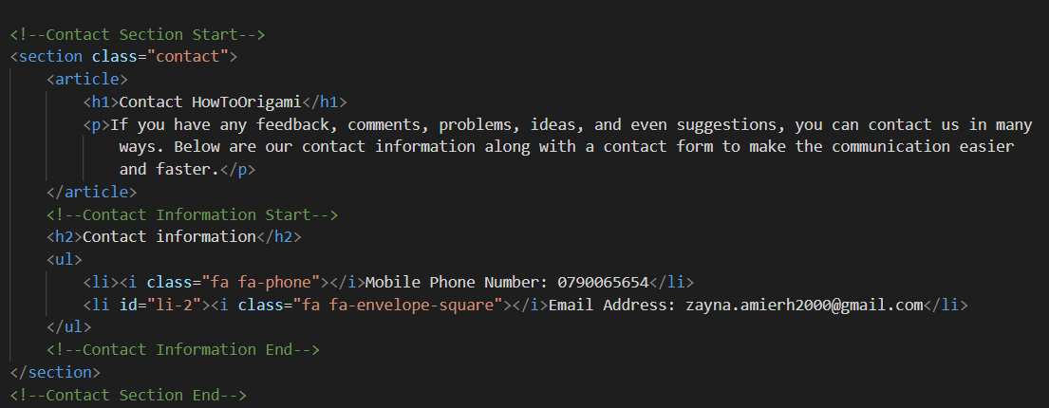

## Use Alt Attributes with Images

Using a meaningful alt attribute with <img> elements is very important for writing valid and semantic code. I also believe it is important for the SEO and also important if the images are unable to load on a user’s devices may be due to the internet connection. Yet, the alt attribute will at least show what the image is and if the user doesn’t know what the image is the alt tag will also help





## Use Meaningful ID and Class Naming

All Classes and IDs should have meaningful names which can help other developers understand the source code furtherly and understand where each item is in the website.

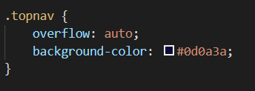

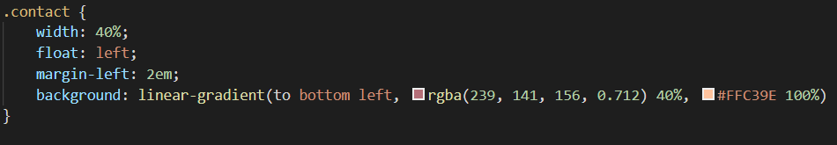

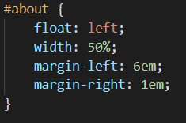

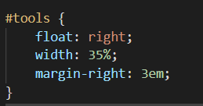

## Use the Title

Use a title tag in the head tag of each page and make sure that each is unique. This is because it helps with the SEO for establishing keyword relevance. The title also shows to the user what the page is about

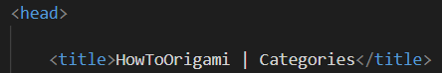

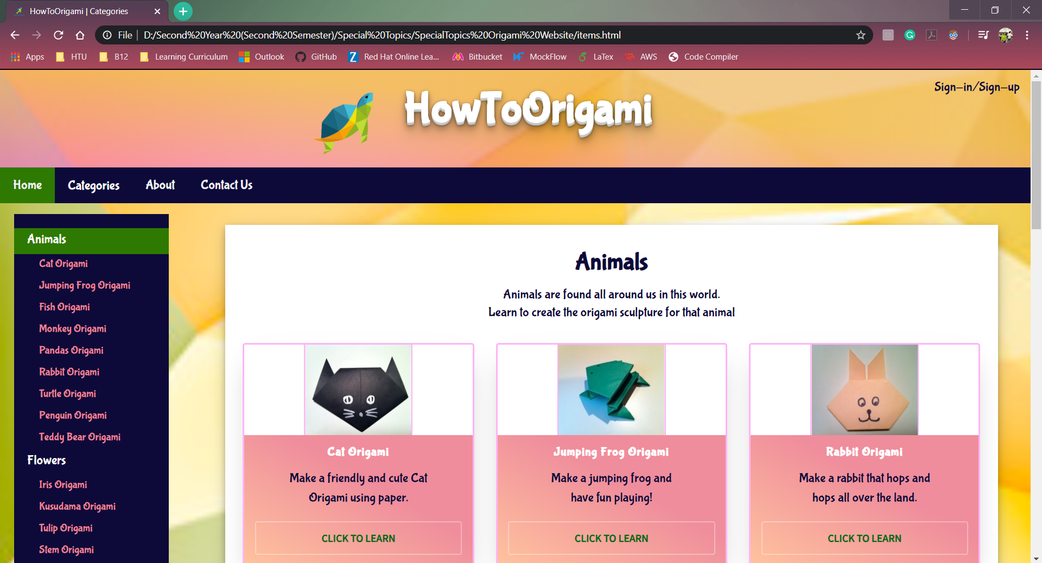

## Logo should go to Home

The logo of the website should always go back to the home page of the website to ensure efficient navigation.

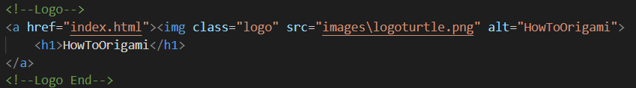

## Backup Fonts

All font styles/faces used in the report should have a backup font so if a browser was unable to load or find the desired font face, then there is an alternative font to use.



## Comments

Comments are an important part of your HTML (and CSS) files, even though the user will never see them this is because it is useful for anyone who will be working on the code of the page. Therefore, the comments will help explain what each part is.

Here is a commenting example:

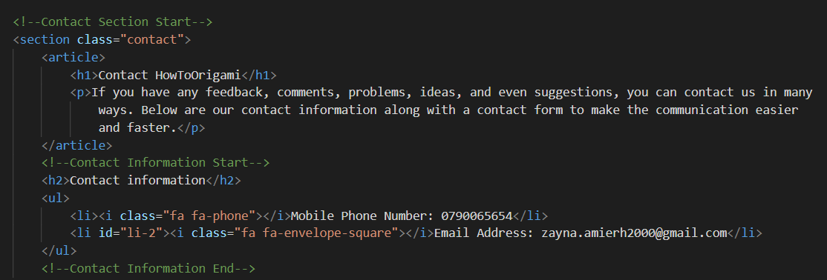

# Structural Elements And Responsive Design

In website design, it is essential to use structural elements and responsive design. This is because responsive websites change the layout to offer user experience according to the devices used, especially for mobile viewing. A responsive website includes readable text without requiring zooming and no horizontal scrolling. Other than this, websites that are not optimized for small screens may experience decline in their search engine rankings.

Furthermore, structural elements are extremely vital to be used in the website for many reasons. In my point of view, semantic HTML is used to communicate an extra layer of information to anything or anyone listening and it only makes a difference to anything out there (human or machine). The structural elements are used to structure the HTML and reinforces semantics of the content rather that its appearance, and this means that the architecture of the site separates the presentation from the content. To use the semantics correctly, we must understand the hierarchy of the content and how both the users and machines will use it. Such that when writing a header, we use the heading tag (<h1>, <h2>, <h3>...) and when writing a paragraph, we use the paragraph tag (<p>). Therefore, we choose and use based on the important and structure of the content.

The main goal is to make it easier for browsers, developers, and crawlers to distinguish between different types of data and the structural elements make it clearer to what the information is on the webpage as well as its importance in order to give information to the search engines, crawlers and even developers what each part of the page is about. Moreover, the main three reasons its important that the website is readable to both humans is due to SEO, accessibility and even maintenance.

(Semantic HTML for Meaningful Webpages, 2020)

## Structural Elements

Structural elements are used to divide the page into major sections to give structure to the page in order to make it easier for us to apply styles to different parts of the page. Also, structural elements make it easier for the users to navigate the page using assistive technology such as a screen reader.

In my website I have used many structural elements. Let’s look at a few examples:

### <nav> Tag

The nav tag structural element has been used for the efficient navigation between pages of the website.



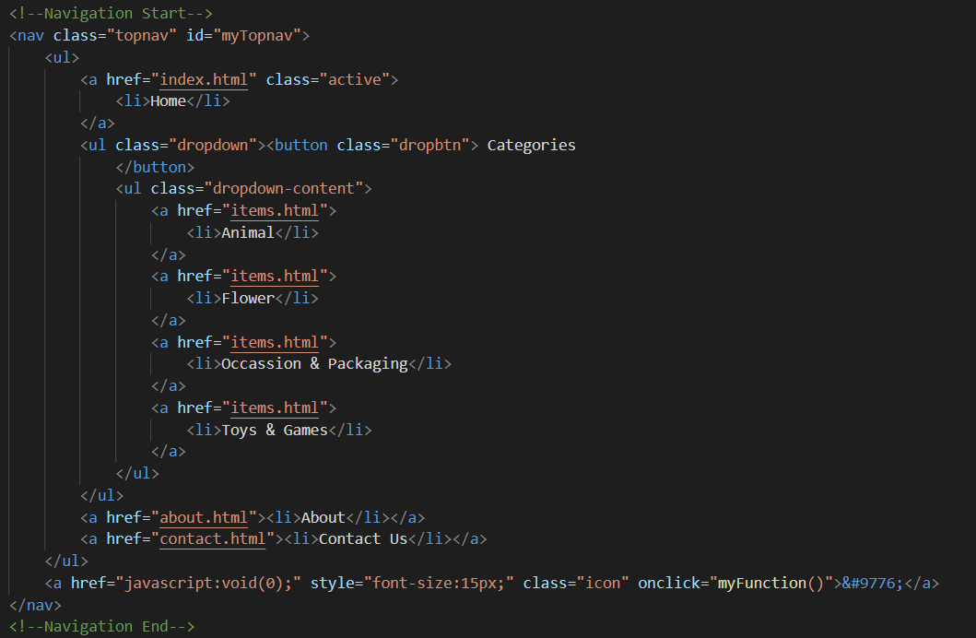

### <header> Tag

The header tag structural element has been used to specifically identify the header of the website

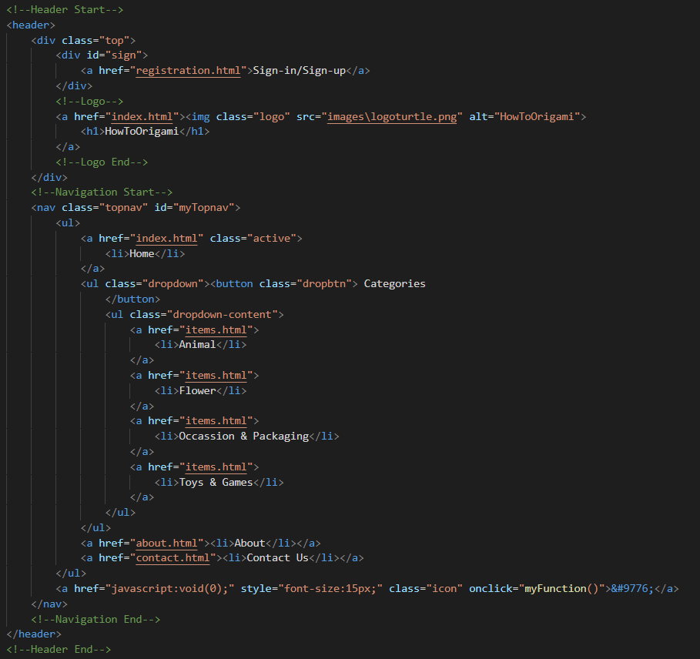

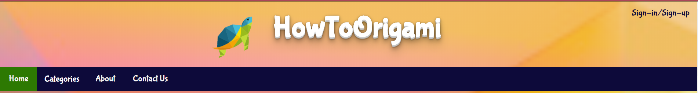

### <section> Tag

This tag is a structural element that has been used to divide the website into sections.

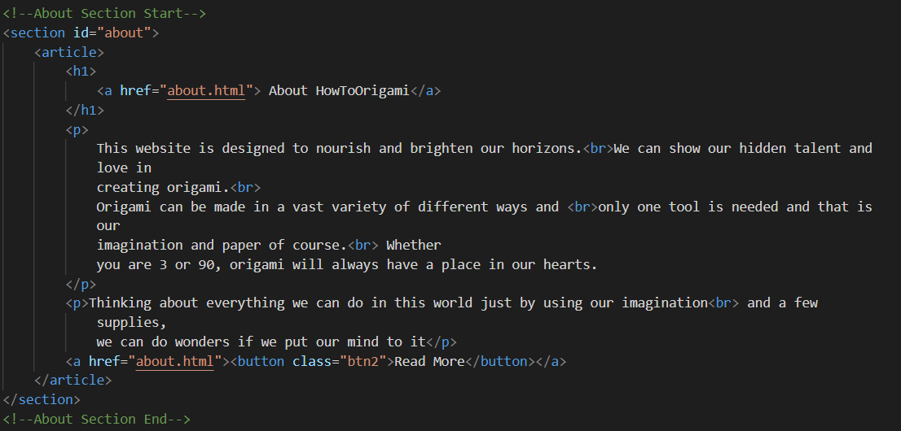

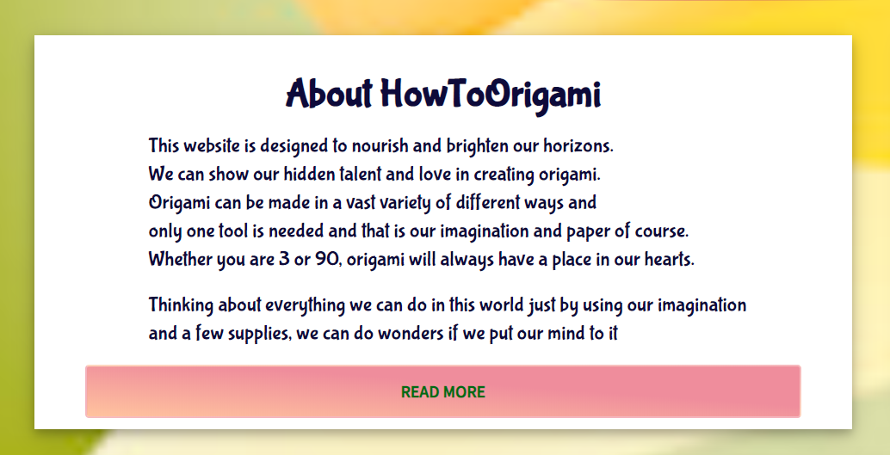

### <aside> Tag

This tag has been used to create a section that can be displayed to a side of the page (left – right usually)

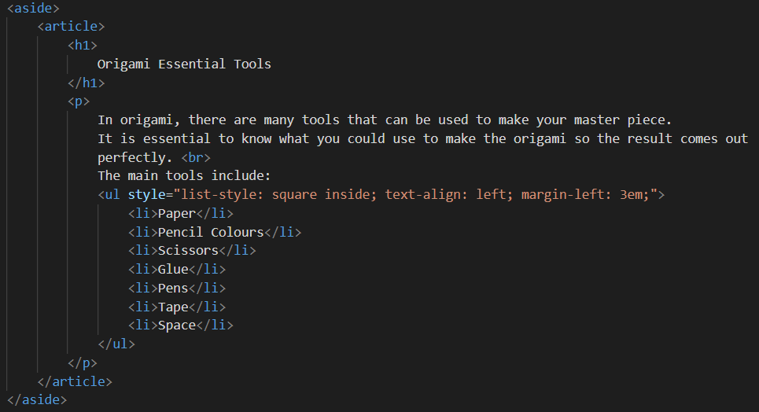

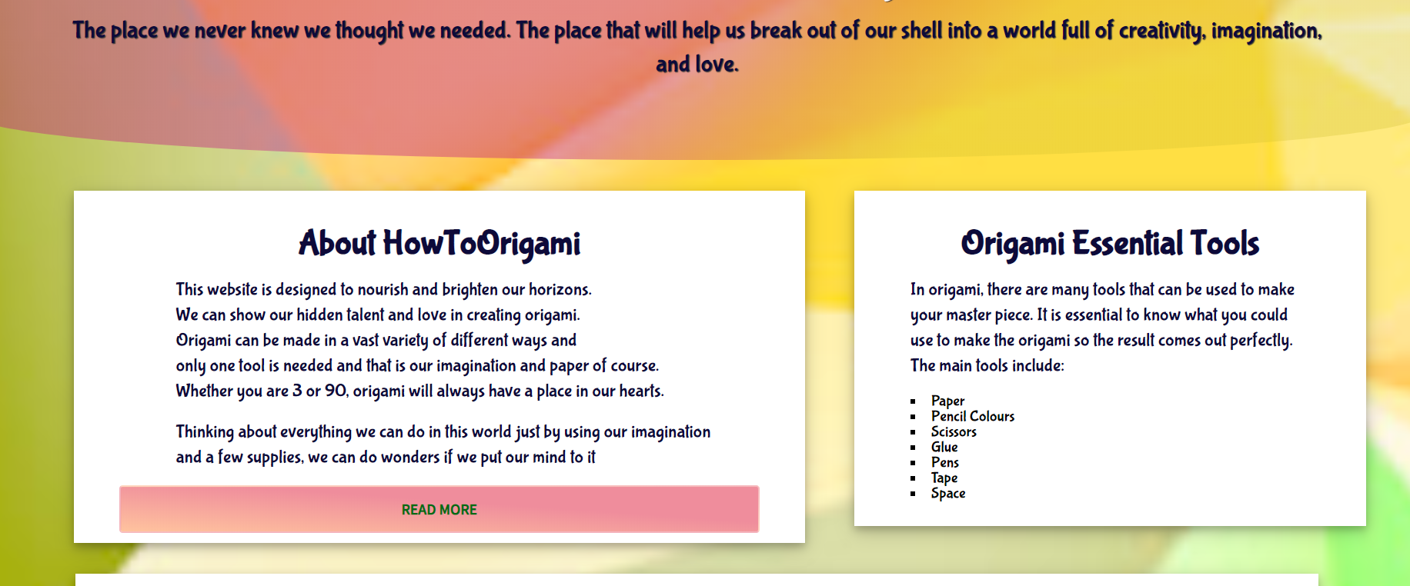

It can also be used to create side navigation bars in the website:

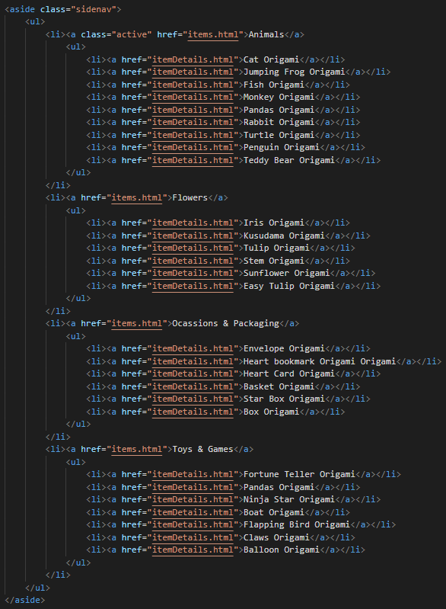

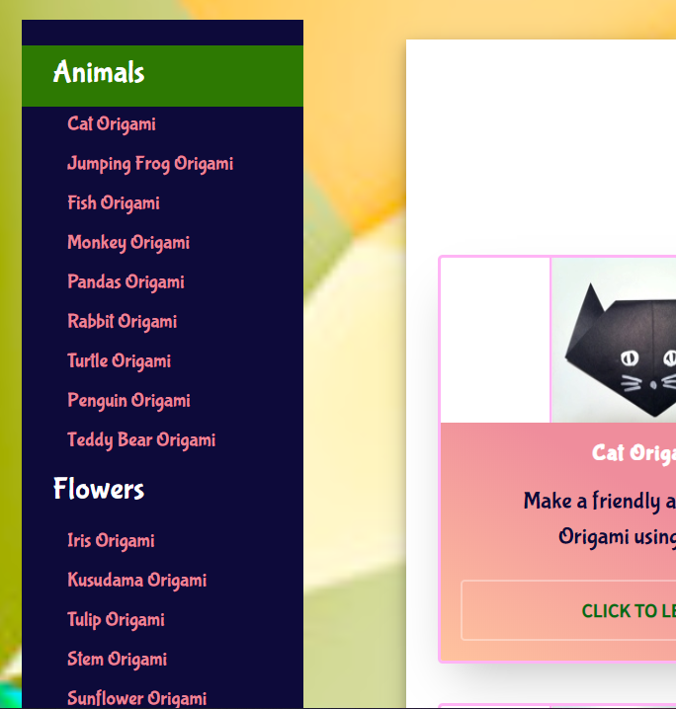

### <article> and <p> Tag

This article tag is a structural element used to focus on writing articles in the website and the p tag is used for creating paragraphs in the website.

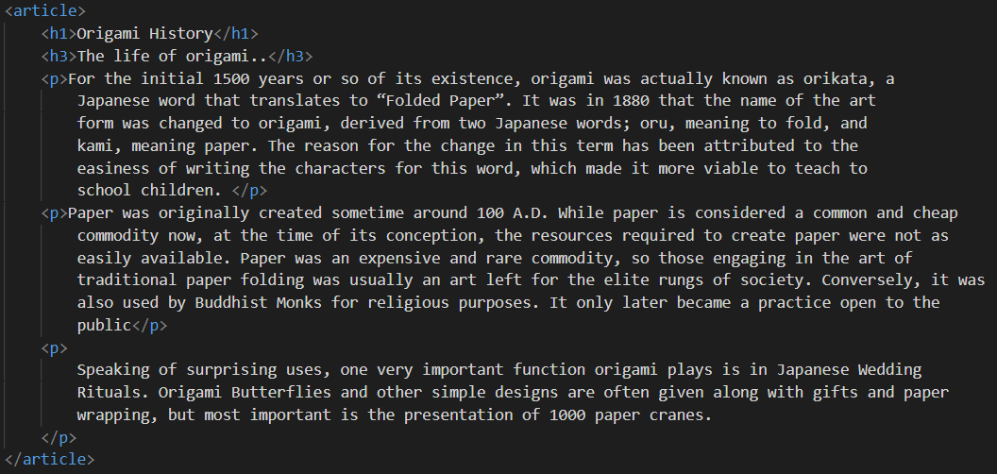

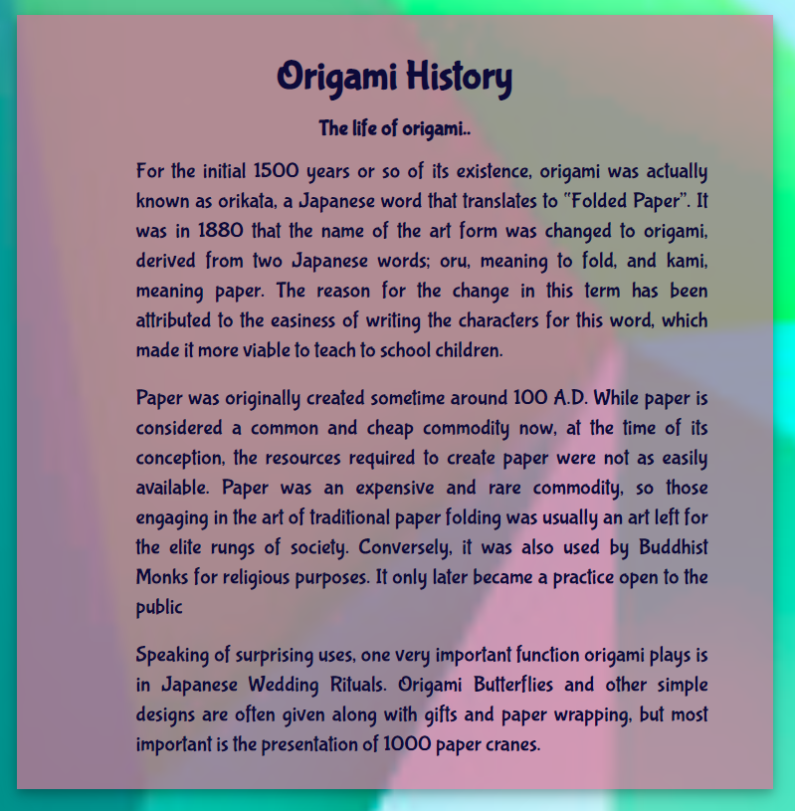

### Footer Tag

This footer tag is a structural tag specifically used to create the footers of the page:

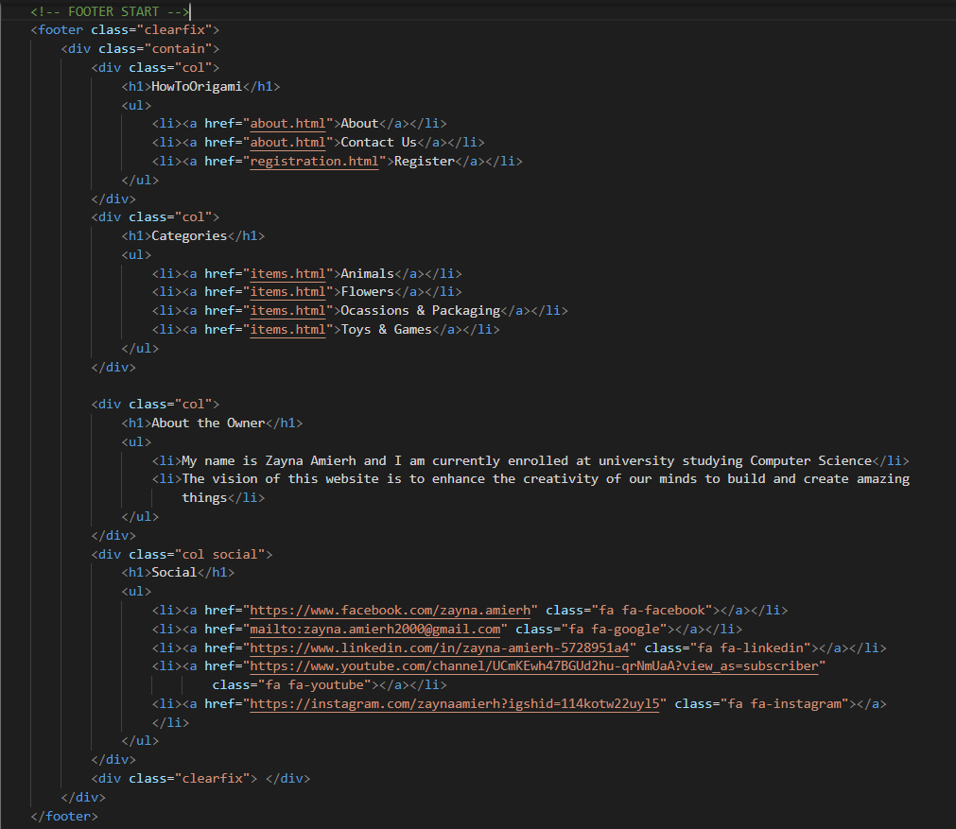



## Use of Responsive Design

As mentioned before, responsive design is a way to make websites easily viewed and used on any device and size of screen (even if it is a mobile phone). With responsive design, there is only one version of a website, whereas nonresponsive websites may have many websites according to screen size or device. Responsive design makes sure you can get all the content and the design will rearrange itself so it fits perfectly on any size screen (so no zooming in or out is needed). Other than this, CSS is the code that the responsive design website is made up and put together using cascade and box model.

### Responsive Typography

Typography is simply making the website content easy to understand. It ensures readability of content across a wide variety of devices and viewports. A few responsive typographies are:

1. Use REM or EM instead of px since REM considers and is relevant to the font size of the container and EM is relative to the font size of the element. Percentage and auto font-size can also be used.

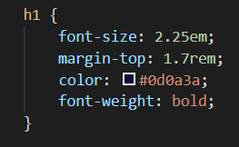

1. Think of line-height and set it to minimum 1em. I have set mine to 1.4~1.5em.

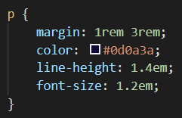

### Media Queries

Media queries are filters that are applied to the CSS style and their main purpose is to make it easier to change the styles based on characteristics of the device whether it may include display type, width, height, orientation and even resolution. We apply the media queries based on viewport size and choose breakpoints based on content and always focus on mobile-first. Also, make sure the lines of texts should be maximum around 70 or 80 characters. Here are a few examples from my website:

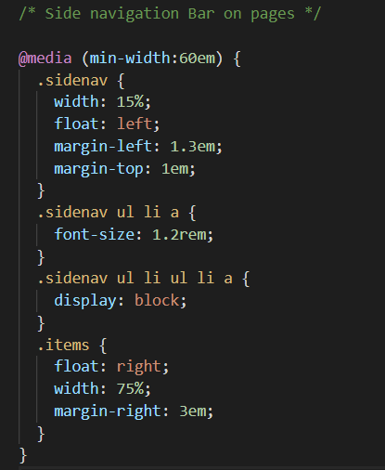

This is the media query about the side navigation of one of the pages. This media query shows what will happen to the format if the minimum width of the screen is 60em. If the width is less than 60em, the following will occur:

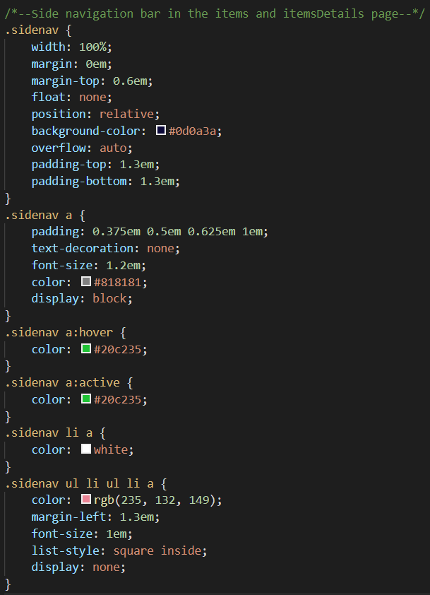

### Mobile-First

It is essential to make sure that you follow the best practice of mobile first where you do the CSS according to a mobile and then you use media queries for bigger screens. The above codes are an example of the mobile first.

### Layout

The layout of the website should be flexible and that comes in many approaches, it may include using grid layout or using flexbox or even using box model positioning and floats. Let’s look at a few layouts that have been used in the website.

To display the cards in the website for the categories and items I have used flex:

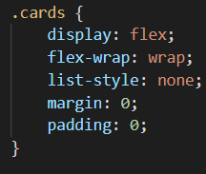

Positioning were used with floats for the arrangement of content where width, position, and float was all identified:

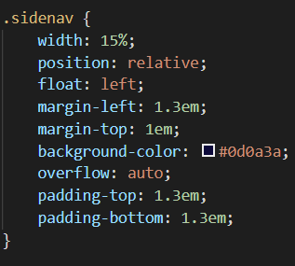

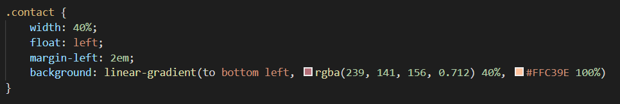

Note: it is essential to make sure that in the CSS we add box-sizing to border-box for responsiveness.

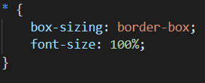

# CSS Cascade

The cascade of CSS is the ability that it gives the browsers to apply rules at different levels in addition to allowing the rules to flow down to subsequent levels. The cascade determines the order in which styles are applied and how the browser chooses among conflicting style rules. The CSS cascade priorities include:

1. !important
2. Inline style
3. ID
4. Class
5. Tag name
6. Inherited
7. Default

Let’s look at a few that have been implemented in my website

## Inline Style

Inline style is the property in the CSS cascade which has higher priority when compared to all other cascades except for !important. Let’s look at this example.

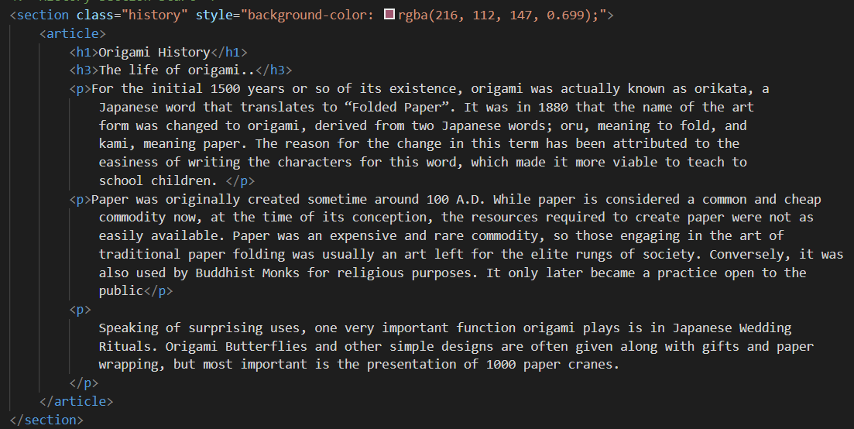

Here the style is found inline in the section (inline style) since all tags of section should have a background as white while here it is pink. Therefore, due to the fact that the inline style has a higher priority than tag names, this section will be pink not white.

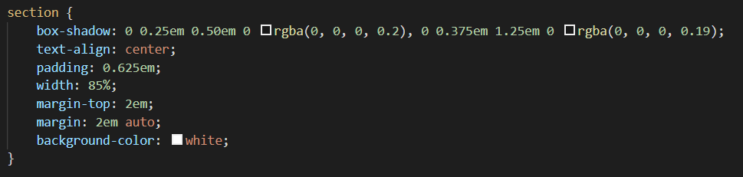

This is the style of the tag section.

## ID

The ID has the higher priority when compared to the class, tag name, inherit, and default. So, if the ID is present with the class, the ID will be implemented. Here is a tiny example:

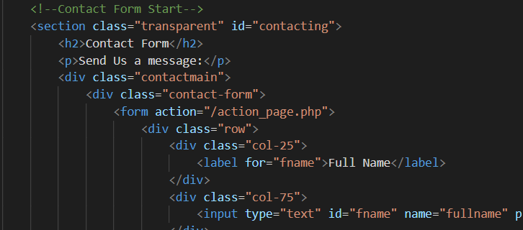

For example, here in the contacting form there is the class “transparent” and the ID contacting. Look at the CSS for the background:

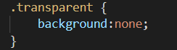

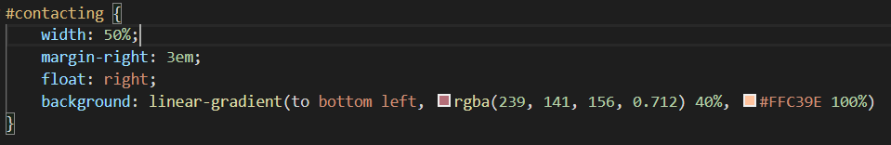

So, due to the priorities, the contacting ID will be implemented and will give the website section a colour as mentioned.

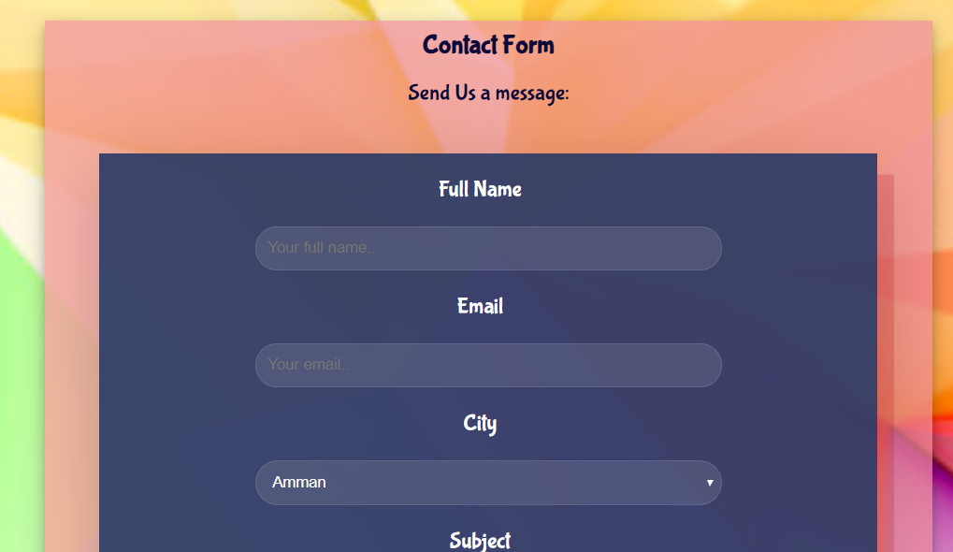

## Class

The class has higher priority when compared to tag names, defaults and inheritance. Therefore, if it is available with those mentioned, it will be implemented. Here is an example from my website.

Here is the section tag with items class. Lets look at the css.

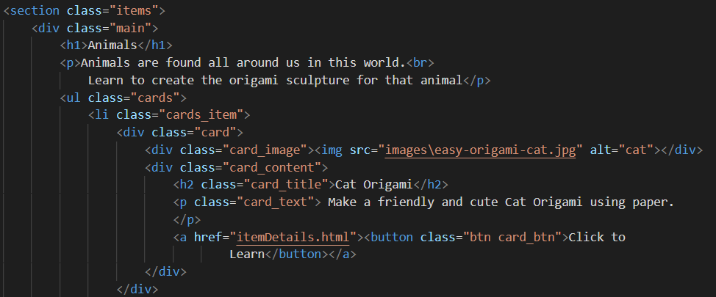

So, it can be seen below that the section tag width should be 85% of the screen although for items class the width should be 75%. Therefore, the class items will be executed due to it having higher priority than the tag section.

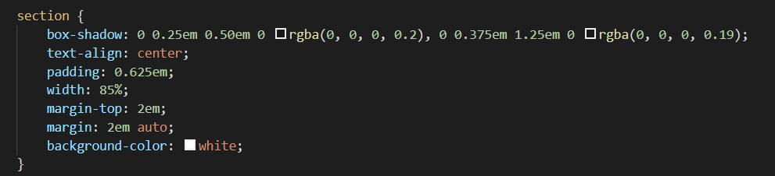

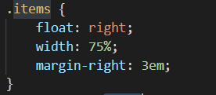

## Inherited

Inherited is only prioritized compared to the default value. Here is a simple example:

Here in the dropdown and dropdown button classes, the attribute font-family is inherited but from where? Well the font-family is inherited from the class top and the body tag name. As a result, the inherited is implemented and not the default value for font-family.

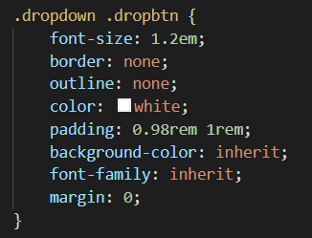

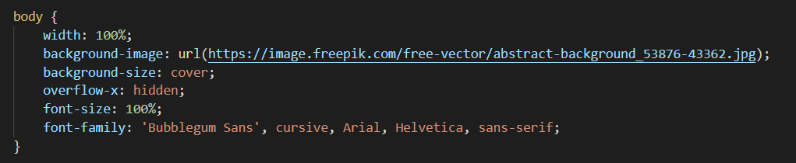

To make it more clear: look at the HTML code below:

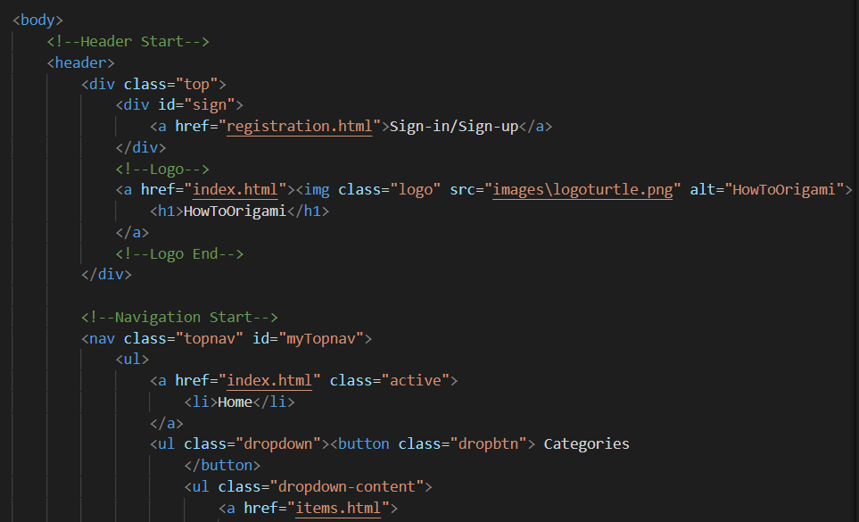

Here is the final result:

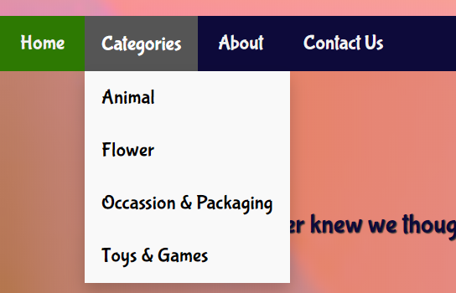

# References

* Smashing Magazine. 2020. Responsive Web Design - What It Is And How To Use It — Smashing Magazine. [online] Available at: <https://www.smashingmagazine.com/2011/01/guidelines-for-responsive-web-design/>.
* Sitepoint.com. 2020. The Meaning And Purpose Of Responsive Web Design — Sitepoint. [online] Available at: <https://www.sitepoint.com/the-meaning-and-purpose-of-responsive-web-design/>.
* Jensen, J., 2020. Responsive Web Design Goals | Hostgator Blog. [online] HostGator Blog. Available at: <https://www.hostgator.com/blog/responsive-web-design-goal-2014/>.
* Brevity Digital Design & Branding. 2020. Semantic HTML For Meaningful Webpages. [online] Available at: <http://seekbrevity.com/semantic-markup-important-web-design/>.